
A 10

Sreenidhi Institute of Science & Technology
(An Autonomous Institution)
Code No: 102EP10
M. TECH. (EPE) I – Year I – Semester Examinations, March, 2011 (Regular)
ADVANCED OPERATION & CONTROL

Time: 3 Hours Max. Marks : 60

Note : No additional answer sheets will be provided.

* * * * *
Part-A (Objective Type)
Max.Marks:10

Answer all the QUESTIONS. ALL QUESTIONS CARRY EQUAL MARKS.

1. Write the coordination equations for thermal system dispatching with network losses being considered.

2. Distinguish between economic dispatch and unit commitment.

3. Write the expression for B-matrix loss formula and define the terms involved.

4. Briefly explain short - range Hydro - scheduling.

5. Mention the purpose of pumped - storage Hydro-plants.

6. What do you understand by "off - line" reserves? Give examples.

7. List any two operation advantages of centrally dispatched power pools.

8. Write the three functions (major) that are carried out in an operations control center for system security.

9. Write the expression for Probability Density Function of a random measurement error and define the terms involved.

10. List the two popular methods used in State Estimations.

Part – B (Subjective Type)
Max. Marks : 50
Answer any Five. All questions carry equal marks.

1. a) What do you understand by dynamic programming and explain how dynamic programming can be applied to find the economic dispatch of the thermal units.
[ 5 ]

b) State the algorithmic steps to solve the non - linear equations involving economic dispatch with network losses considered. [ 5 ]

2. a) Draw the flow chart for economic dispatch using B - Matrix loss formula with updated penalty factor and explain briefly. [ 5 ]

b) What is meant by unit commitment? Briefly explain. Indicate various techniques available for the solution of the unit commitment problem. [ 5 ]

3. The fuel cost of the first, second & third units are 1.2, 1.3 & 1.4 Rs./ Mbtu respectively. The input - output curves for units are as given below:
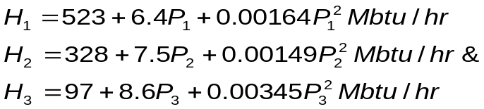
100 MW ≤ P₁ ≤ 550 MW, 150MW ≤ P₂ ≤ 550 MW & 60 MW ≤ P₃ ≤ 225 MW. Find the economic dispatch solution for a load of 700 MW. [ 10 ]

4. a) Briefly explain the problem of scheduling hydro - thermal power plants. What are constraints in the problem? [ 5 ]

b) A hydro plant and steam plant are to supply a constant load of 90 MW for one week. The unit characteristics are : [ 5 ]
Hydro plant : ⇒ 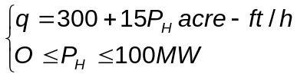
Steam plant: ⇒ 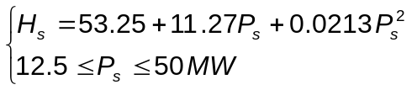
Let the hydro plant be limited to 10,000 MWh of energy, work out the resulting schedule.

5. a) Bring out the specific advantages of interconnected utilities. Give some practical examples. [ 4 ]

b) Write a short notes on the following. [ 6 ]
i) power pools ii) wheeling

6. a) Explain the function of security - constrained optimal power flow w.r.t power system security. Define the different operating states involved in this function and explain them with an example. [ 7 ]

b) Discuss, brief, various factors which affect power system security. [ 3 ]

7. a) Bring out the need for state estimation in a large power system. [ 3 ]

b) Using matrix formulation, derive an expression for estimated value of a parameter which includes the co-variance matrix of measurement errors. Based on the comparison between "N_{m}" number of measurements and "N_{s}" number of samples being measured, write the simplified expression for the estimated value of a parameter being measured. [ 7 ]

------

